**KEGIATAN PRAKTIKUM**

**Percobaan 1. Substitusi Pengganti Gerbang Logika**

1. Buat dengan menggunakan gerbang NOR (IC 4001), SW-SPDT, dan logic probe! Pilih VCC dan ground dari terminal mode.

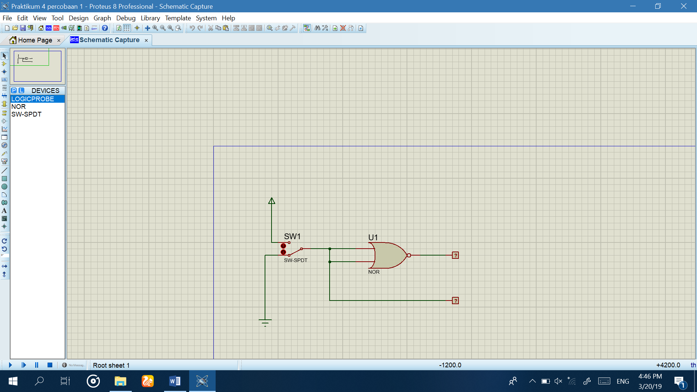

1. Fungsi Boolean : **L1 = $\overline{L2 + L2}$**  = $\overline{L2}$
2. Tabel kebenaran

|  |  |  |
| --- | --- | --- |
| SW 1 | L2 | L1 |
| 0 | 0 | 1 |
| 1 | 1 | 0 |

1. Diagram waktu

L2

|  |  |
| --- | --- |
|  | 1 |
| 0 |  |

L1

|  |  |
| --- | --- |
| 1 |  |
|  | 0 |

1. Kesimpulan:

Gerbang NOR pada gambat tersebut membentuk logika dari gerbang NOT

**Percobaan 2. Substitusi Pengganti Gerbang Logika**

1. Buat dengan menggunakan gerbang NOR (IC 4001), SW-SPDT, dan logic probe! Pilih VCC dan ground dari terminal mode.

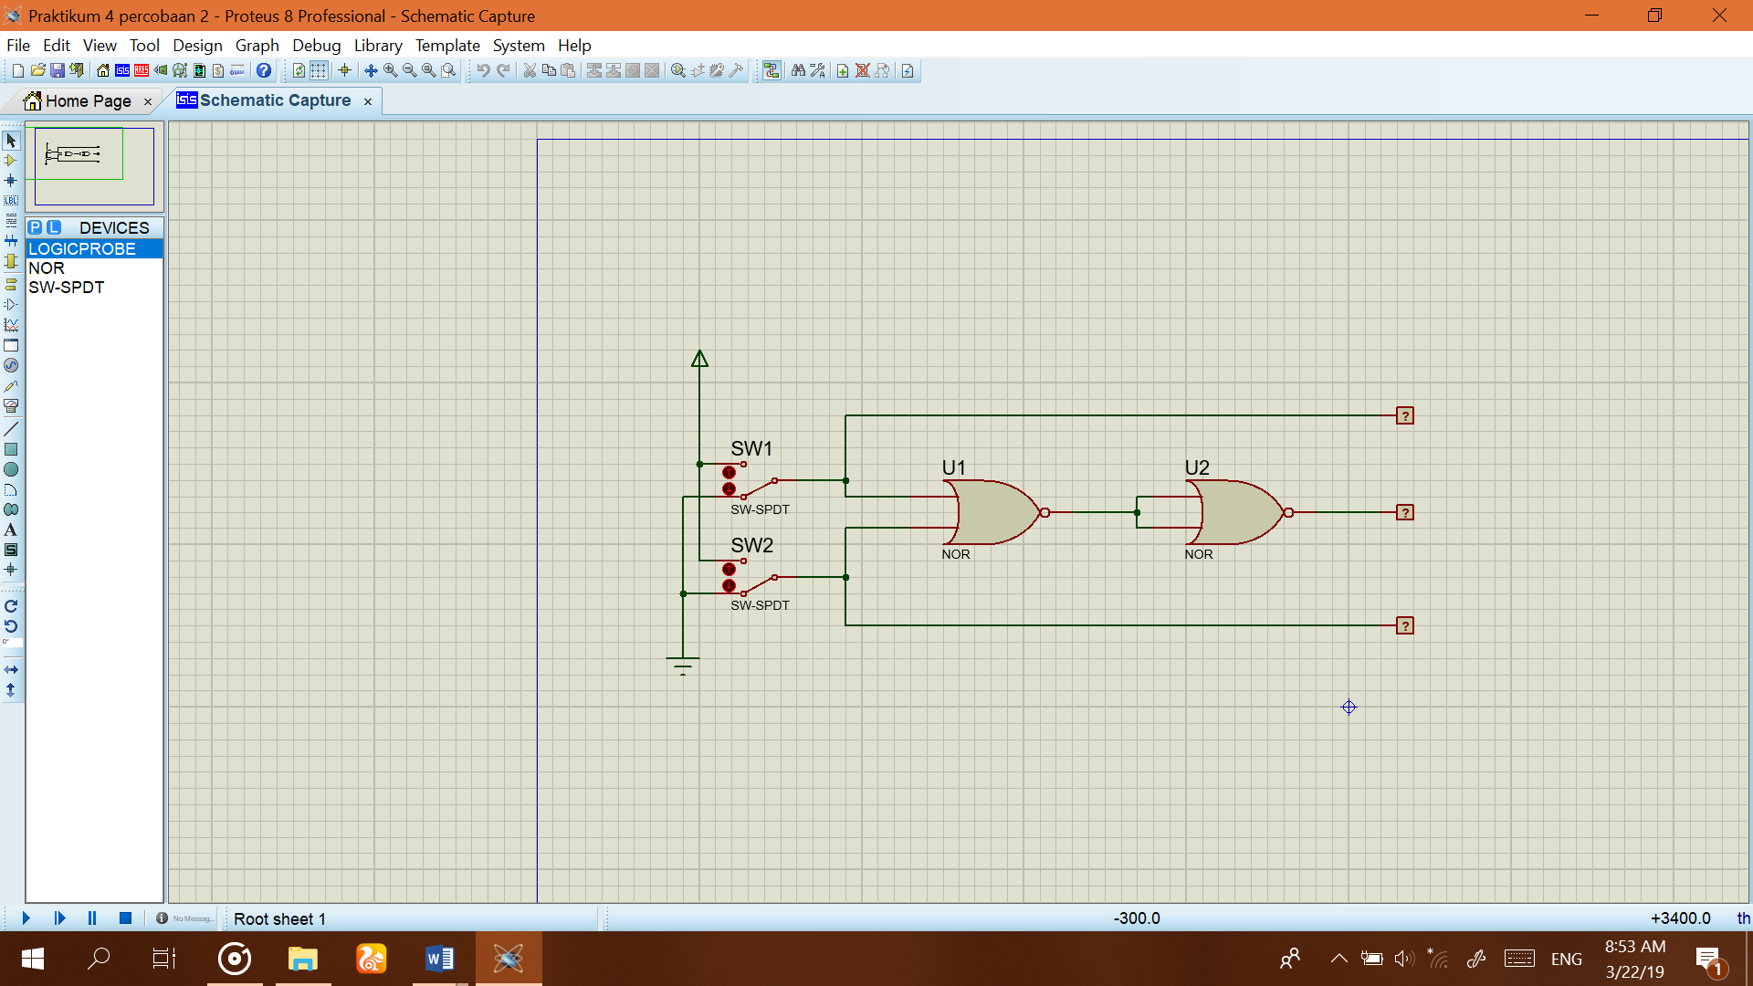

1. Fungsi Boolean : **L3 = $\overline{\overline{L1 + L2}}$ = L1 + L2**
2. Tabel kebenaran

|  |  |  |  |  |
| --- | --- | --- | --- | --- |
| SW 1 | SW 2 | L1 | L2 | L3 |
| 0 | 0 | 0 | 0 | 0 |
| 1 | 0 | 1 | 0 | 1 |
| 0 | 1 | 0 | 1 | 1 |
| 1 | 1 | 1 | 1 | 1 |

1. Diagram waktu

L1

|  |  |  |  |
| --- | --- | --- | --- |
|  | 1 |  | 1 |
| 0 |  | 0 |  |

L2

|  |  |  |  |
| --- | --- | --- | --- |
|  |  | 1 | 1 |
| 0 | 0 |  |  |

L3

|  |  |  |  |
| --- | --- | --- | --- |
|  | 1 | 1 | 1 |
| 0 |  |  |  |

1. Kesimpulan:

Gerbang NOR pada gambar tersebut membentuk logika dari gerbang OR

**Percobaan 3. Substitusi Pengganti Gerbang Logika**

1. Buat dengan menggunakan gerbang NOR (IC 4001), SW-SPDT, dan logic probe! Pilih VCC dan ground dari terminal mode.

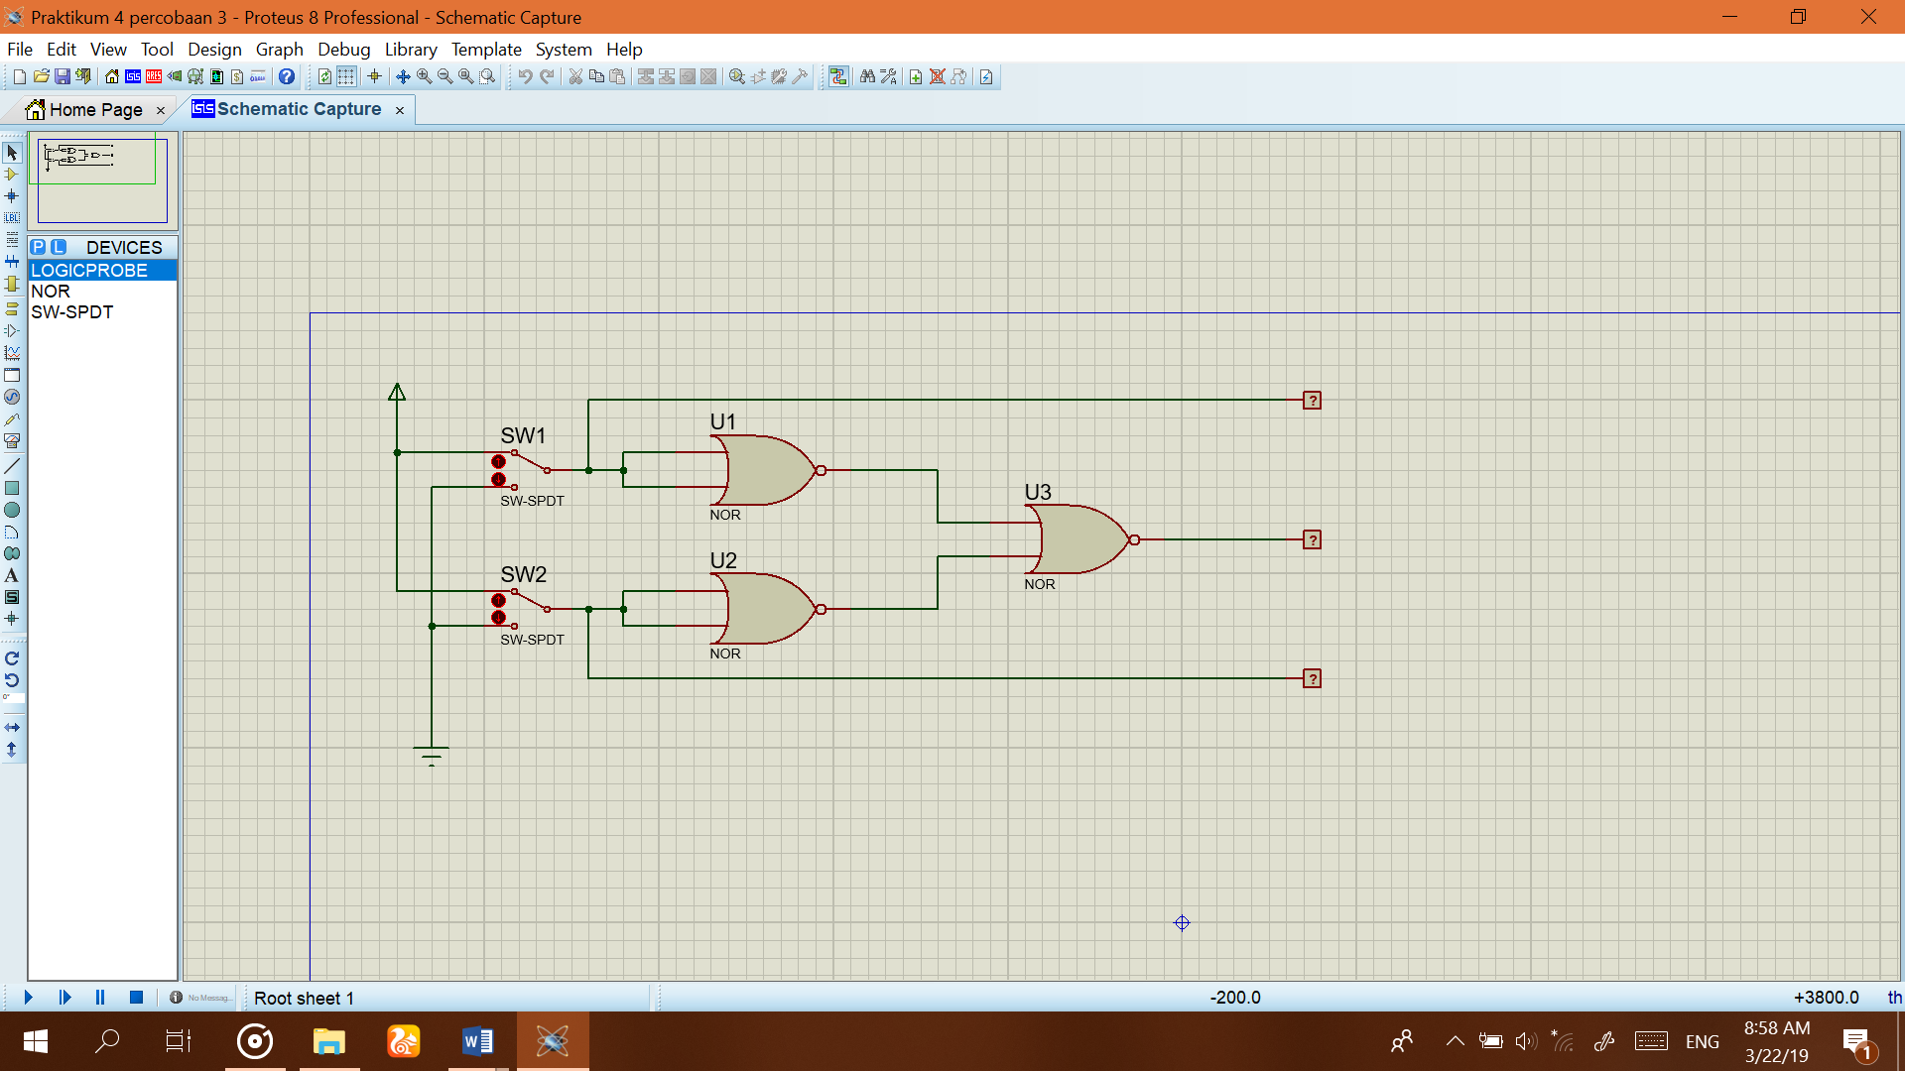

1. Fungsi Boolean : **L3 = $\overline{\overline{L1}+ \overline{L2}}$** = **L1.L2**
2. Tabel kebenaran

|  |  |  |  |  |
| --- | --- | --- | --- | --- |
| SW 1 | SW 2 | L1 | L2 | L3 |
| 0 | 0 | 0 | 0 | 0 |
| 1 | 0 | 1 | 0 | 0 |
| 0 | 1 | 0 | 1 | 0 |
| 1 | 1 | 1 | 1 | 1 |

1. Diagram waktu

L1

|  |  |  |  |
| --- | --- | --- | --- |
|  | 1 |  | 1 |
| 0 |  | 0 |  |

L2

|  |  |  |  |
| --- | --- | --- | --- |
|  |  | 1 | 1 |
| 0 | 0 |  |  |

L3

|  |  |  |  |
| --- | --- | --- | --- |
|  |  |  | 1 |
| 0 | 0 | 0 |  |

1. Kesimpulan :

Gerbang NOR pada gambar tersebut membentuk logika dari gerbang AND

**Percobaan 4. Substitusi Pengganti Gerbang Logika**

1. Buat dengan menggunakan gerbang AND, NOT, OR, SW-SPDT, dan logic probe! Pilih VCC dan ground dari terminal mode.

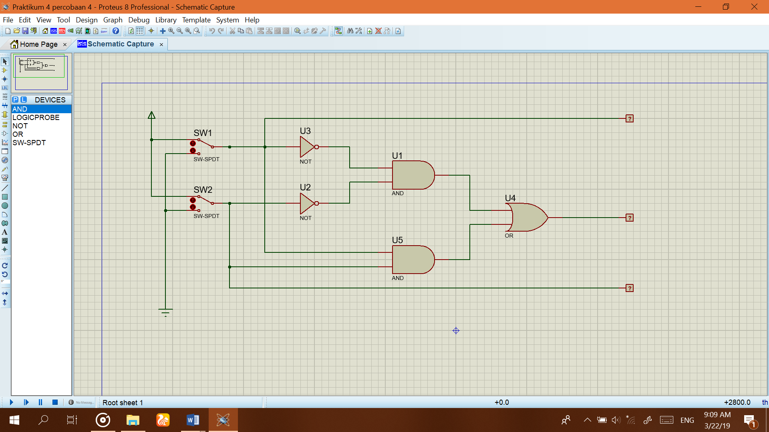

1. Fungsi Boolean : **L3 = $\overline{L1 L2}$** + **L1 L2 = $\overline{L1⊕L2}$**
2. Tabel kebenaran

|  |  |  |  |  |
| --- | --- | --- | --- | --- |
| SW 1 | SW 2 | L1 | L2 | L3 |
| 0 | 0 | 0 | 0 | 1 |
| 1 | 0 | 1 | 0 | 0 |
| 0 | 1 | 0 | 1 | 0 |
| 1 | 1 | 1 | 1 | 1 |

1. Diagram waktu

L1

|  |  |  |  |
| --- | --- | --- | --- |
|  | 1 |  | 1 |
| 0 |  | 0 |  |

L2

|  |  |  |  |
| --- | --- | --- | --- |
|  |  | 1 | 1 |
| 0 | 0 |  |  |

L3

|  |  |  |  |
| --- | --- | --- | --- |
| 1 |  |  | 1 |
|  | 0 | 0 |  |

1. Kesimpulan :

Kombinasi gerbang pada gambar tersebut membentuk logika dari gerbang XNOR

**Percobaan 5. Merancang fungsi Boolean ke dalam rangkaian**

1. Buat kombinasi gerbang logika berdasarkan Fungsi Boolean **L3 = $\overline{L1}$ L2 + L1 $\overline{L2}$**
2. Gambar kombinasi gerbang logikanya!

Gambar dari fungsi **L3 = $\overline{L1}$ L2 + L1 $\overline{L2}$**

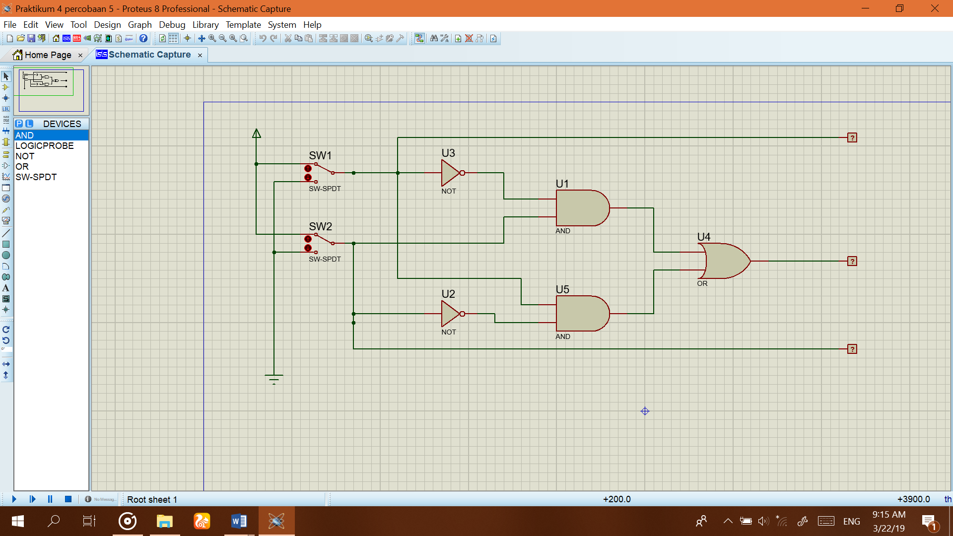

1. Tabel kebenaran

|  |  |  |  |  |
| --- | --- | --- | --- | --- |
| SW 1 | SW 2 | L1 | L2 | L3 |
| 0 | 0 | 0 | 0 | 0 |
| 1 | 0 | 1 | 0 | 1 |
| 0 | 1 | 0 | 1 | 1 |
| 1 | 1 | 1 | 1 | 0 |

1. Diagram waktu

L1

|  |  |  |  |
| --- | --- | --- | --- |
|  | 1 |  | 1 |
| 0 |  | 0 |  |

L2

|  |  |  |  |
| --- | --- | --- | --- |
|  |  | 1 | 1 |
| 0 | 0 |  |  |

L3

|  |  |  |  |
| --- | --- | --- | --- |
|  | 1 | 1 |  |
| 0 |  |  | 0 |

1. Kesimpulan :

Kombinasi gerbang akan membentuk logika dari gerbang XOR